**Risk Assessment**

<https://trello.com/b/4dJFFzY3/risk-assessment>

The Trello link gives a risk assessment of the project and shows all the possible risks that occur during production as well during the use of the product.

Risks of using the app.

Risks that happen during the production of the app.

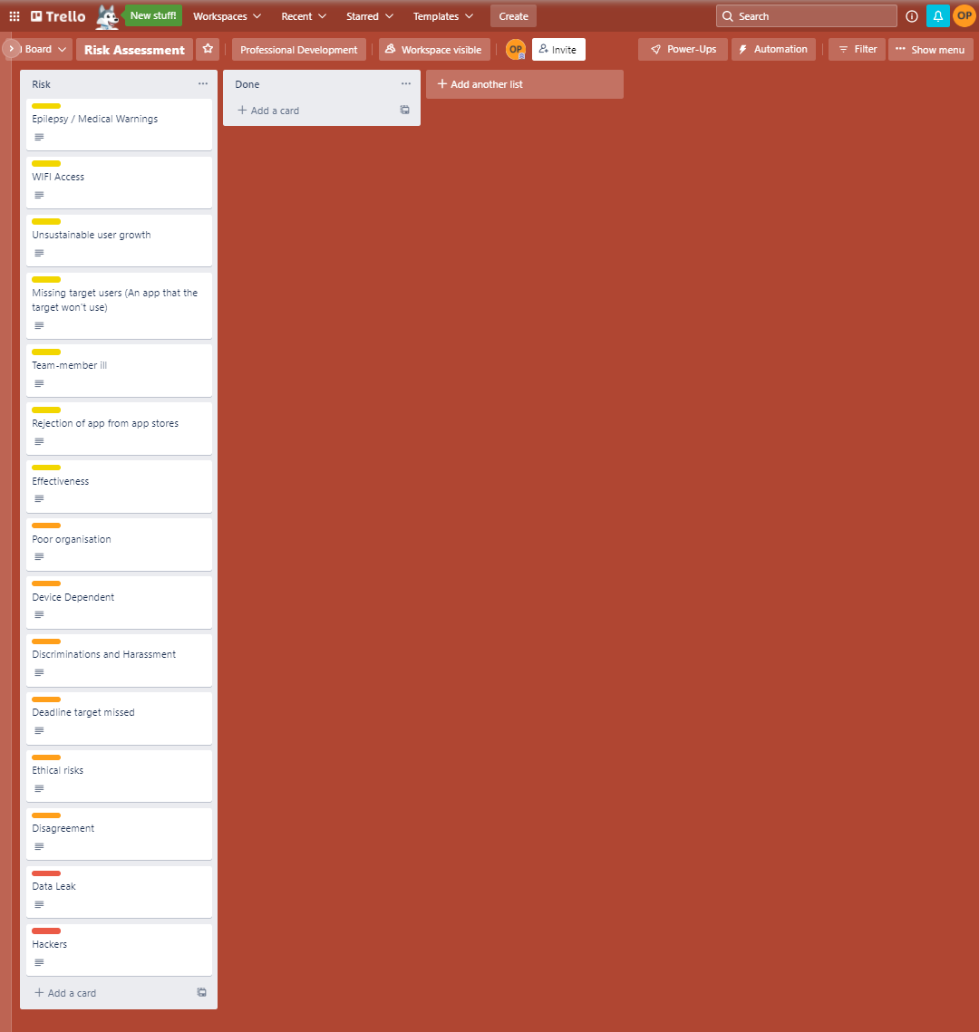

Risks separated into before and after deployment

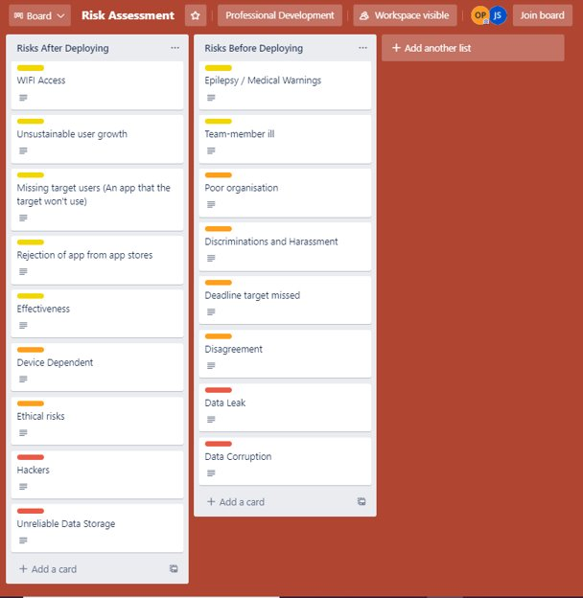

**Evidence of Project Management**

Trello board tracks progress and allows the team to plan tasks out together and see what needs to be done before the deadline.

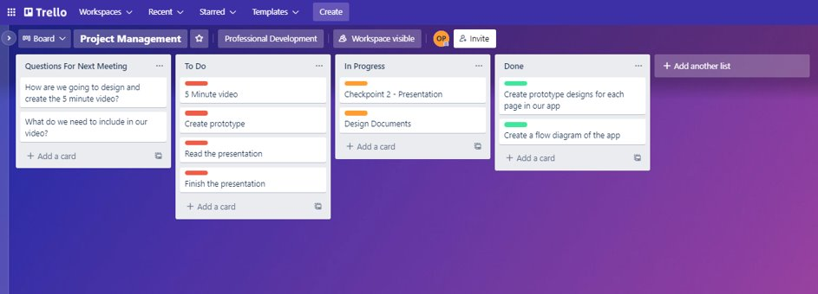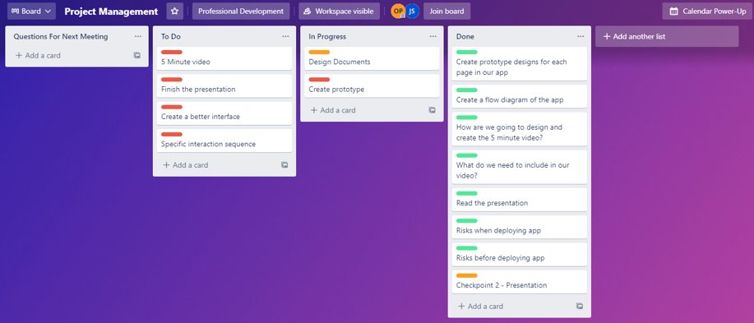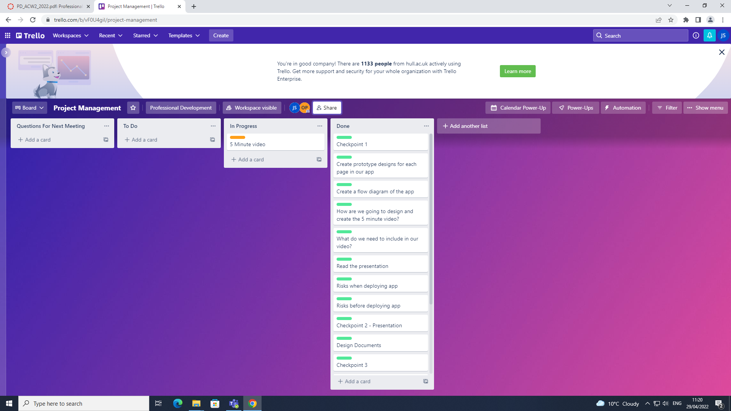

We also used the teams chat to communicate ideas with other members of the team.

